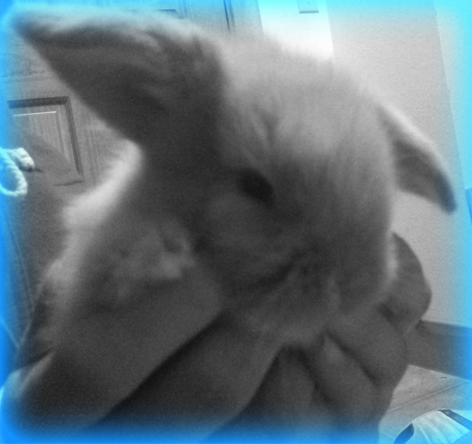
Before After
To complete my photo editing artifact I chose to use the web tool iPiccy. I chose iPiccy after doing my evaluations because it seemed simple to navigate, but had a lot of features. The website allowed me to play around on it without having to make an account or even upload my own picture. iPiccy has all of the standard photo editing tools, but also has some unique enhancing tools that I found to be unique such as retro comic, cyber vision, and posterize.
To complete my artifact I began by uploading my picture onto the website. I began by cropping down the image to just the rabbit, I then “fixed image” to make my picture clearer. After I made the photo clearer, I then brightened it before changing the color to colors to black and white. Once the photograph was black and white, I added a blue vignette to add some color to the image making a slight border.
Although I gave this website a high ranking for working during busy times of the day, I misjudged it in that short time. In my time trying different options on the website on at least three different occasions once I clicked on the effect the photo began “loading,” but would never finish. I tried a few different things, but it always ended up coming down to having to leave the page and losing all of the changes I had made to my photo. Once I had completed my photo, when I attempted to save it the website closed without saving my picture losing all of the changes I made. When I went back and redid my editing when I got to the saving page there was an option for if you were having trouble saving which luckily worked for me. I once again then tried to save it from the original menu and it again closed the webpage. Because of their alternative saving option the company obviously knows that there is a problem and has probably made many people upset when they lost all of their hard work by simply trying to save their photo.
After my experience with iPiccy I would not use it again, although it had some cool options and was simple to use, for the hassle it caused not saving and loading it was just really a pain. With all of the free photo editing tools available, I just don’t think this one is worth messing with.

